# Exercises on arrays

## Exercise 08.01

* Create an array of the 12 months of the year.
* Set the data correct.
* Show in the console every value, by looping thru the elements.

## Exercise 08.02: C# arrays

* <https://www.w3schools.com/cs/exercise.asp?filename=exercise_arrays1>
  + Exercise 1.
  + Exercise 2.
  + Exercise 3.
  + Exercise 4.
  + Exercise 5.

## Exercise 08.03: Bubble Sort

See for explanation “Leren programmeren – Deel 08 – Algoritmes, slides 5 till 12 of the first module in learning to program.

|  |  |
| --- | --- |
|  |  |
|  | We are going to sort an array. Normally you use the method .Sort() for doing that. Here we do some style exercises to do it by ourselves. The goal of the exercise is to sort the array by yourself.  Please, do not download the solution from internet. Try it by yourself, if you want to learn something. |
|  |  |

* You declare and assign an array (1 dimension, several values).
* You program a method to sort an array.
  + Input is an array, output is a sorted array.
* You are programming this algorithm below.
* Loop thru the elements of the array.
  + indexOfLastNotSorted = Length of the list minus index of current element minus 1. Current element is the loop position.
  + Loop from 0 to indexOfLastNotSorted minus 1.
    - If element on current position of inner loop is bigger than element next position of inner loop.
      * Remember value of element on current position.
      * Element on current position becomes element of next position.
      * Element on next position becomes the remembered value.
  + Continue with loop (inner loop).
* Continue with loop (outer loop, current element).

### Variant 1

* You stop with the first loop, when no items are switched in the second loop. This means that they are already in the correct order.

## Exercise 08.04: Insertion Sort

See for explanation “Leren programmeren – Deel 08 – Algoritme, slides 13 till 17 of the first module in learning to program.

|  |  |
| --- | --- |
|  |  |
|  | This is just an exercise to getting used to work with arrays.  Please, do not download the solution from internet. Try it by yourself, if you want to learn something. |
|  |  |

* You declare and assign an array (1 dimension, several values).
* You program a method to sort an array.
  + Input is an array, output is a sorted array.
* You are programming this algorithm.
* Loop thru the elements of the array, except the first one.
  + Remember the value of the current element.
  + Loop from current position towards the second position.
    - If element on the position before the current position is bigger than remembered element.
      * Replace element on current position with the one on the position before the current position.
      * Continue with loop (inner loop).
    - If Not.
      * Exit the loop (inner loop).
  + Place the remembered value on the position where you ended the loop.
* Continue with loop (outer loop).

### Variant 1

* Make the array a bit bigger, and put randomly values in the array. Try it out with the size of 50, 100, 200, 10.000, 100.000.
* Look at the time it takes to execute.

## Exercise 08.05: Merge sort

See for explanation “Leren programmeren – Deel 08 – Algoritmes, slides 13 till 21 of the first module in learning to program.

|  |  |
| --- | --- |
|  |  |
|  | This is just an exercise to getting used to work with arrays.  Please, do not download the solution from internet. Try it by yourself, if you want to learn something. |
|  |  |

* You declare and assign an array (1 dimension, several values).
* You program a method to sort an array.
  + Input is an array, output is a sorted array.
* You are programming this algorithm.
* You divide the array in 2 parts when the size is bigger than 1. When the size is one, it is sorted.
  + 2 possibilities for arrays bigger than 1.
    - The sizes are equal (when number of elements is even).
    - The first one is 1 smaller than the other (when number of elements is odd).
    - Restart the same routine with the 2 smaller arrays you now have.
  + Put the 2 results back together, by creating an array and putting the elements of 2 smaller arrays in the correct order.
    - By taking the smallest element of the not yet taken elements of both smaller arrays.
* You end up with a sorted array.

|  |  |
| --- | --- |
|  |  |
|  | See the picture below for what is exactly asked.  Ask questions to colleagues if things are not clear.  First work out a battle plan (User Story and Tasks) on the things that you want to do. And estimate them. |
|  |  |

### An example on how the routine works

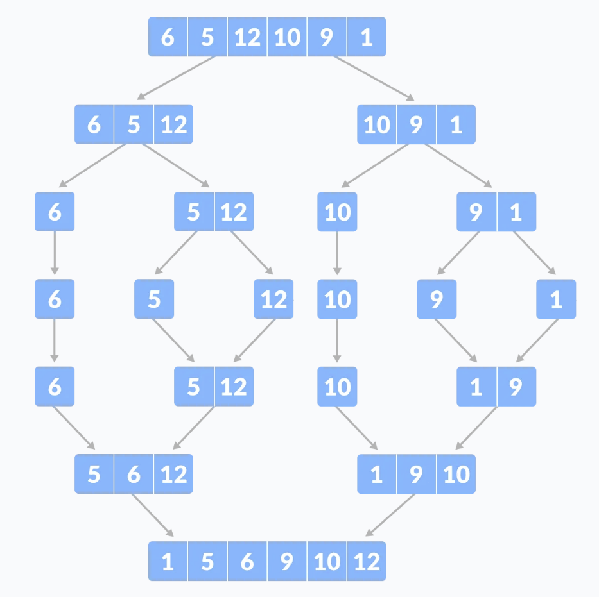

### Variant 1

* Compare the speed of all the algorithms with random generated arrays of size:
  + 100
  + 1.000
  + 10.000
  + 100.000
  + 1.000.000

# Exercises that will take a bit of time

|  |  |
| --- | --- |
|  |  |
|  | The goal of this exercises is to think about on how you get to your solution and to keep your solution as maintainable as possible.  Write down tasks. Think about their size (volume of work).  Try to execute. |
|  |  |

## Exercise 08.06

Having some fun with basic calculations and small numbers.

* The goal is to have on the console every number between 1 and 15, to be multiplied with every number between 1 and 15.
* First, 1 multiply with 1 till 15.
* Then, 2 multiply with 1 till 15.
* …
* As last 15 multiply with 1 till 15.

|  |  |
| --- | --- |
|  |  |
|  | Use in the text you write to the console the escape symbol \t to have a tab between the numbers.  See documentation Leren Programmeren – Deel 03 – C# Data Types, slide 9 and 10. |
|  |  |

### Example result

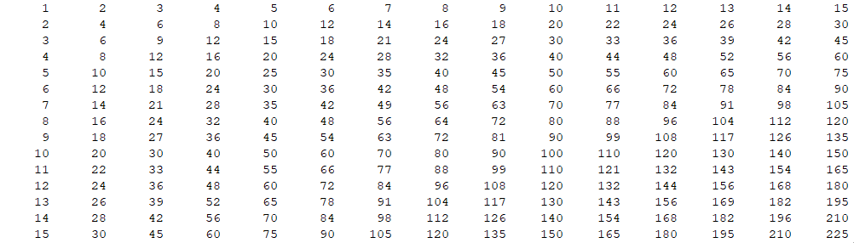

### Variant 1

* Ask the maximum number, so you can create the multiply table as big as you want.

|  |  |
| --- | --- |
|  |  |
|  | In the console, the layout will be put wrongly in the console, because you have only 80 characters.  But that is not a problem for this exercise. The goal is to try-out loops inside loops. |
|  |  |

### Variant 2

* You add titles on top and on the left side of the table.
* Use a “-“ for placing a line horizontal, and “|” to place a line vertically.
* Make sure that the horizontal line has the correct length ("--------").

### Variant 3

* You do only the half of the work, because 10 * 15 is the same as 15 * 10.
* Pay attention. Horizontal till x and vertically till x-1.

### Example result variant 2 and 3

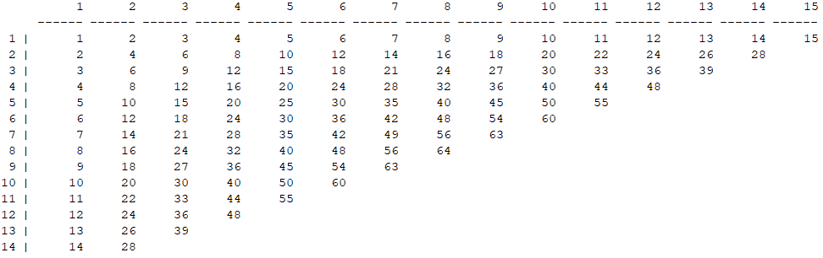

### Variant 4

* Do you see something strange in the result of exercise variant 3?
* How can you correct it?

### Variant 5

* Repeat this table for other operators.
  + First the “+”.
  + Then the “-“.
  + Then the “*”.
  + Then the whole division. Operator “\”.
  + Then the rest after division. Operator “%”.

|  |  |
| --- | --- |
|  |  |
|  | Do not repeat your code, but create a method that accepts one parameter.  The operator that must be used to calculate is the given variable for the routine. |
|  |  |

## Exercise 08.07

* Loop all the numbers between 100 and 1234.
* Within the loop these are the steps you must do.
  + Example is given with number 471.
  + Make from the number 471 a text.
    - You have a text “471”.
  + Put 2 times that text after each other.
    - You have a text “471471”.
  + Make from that text a number.
    - You have the number 471471.

|  |  |
| --- | --- |
|  |  |
|  | There are other ways to do this.  e.g., You can do this: Number * 1000 + Number, but when you have 1000 or more, the way of calculating changes.  Just do it like described above. |
|  |  |

* + Divide that number with 7.
  + Take the result and divide this by 11.
  + Take the result and divide this by 13.
  + You have an end result.
  + If that end result is different than the number you have started with (471), exit the loop.
* Show on the console, the number that causes the exit of the loop.

## Exercise 08.08

Having some fun with basic calculations and big numbers.

|  |  |
| --- | --- |
|  |  |
|  | This exercise will force you to work in small steps.  Test every time your small step is a good one.  Check also the speed of your solution. |
|  |  |

### Part 1: Calculating the persistence of a number in a method (not main)

* Take a number.
  + Example: 88.
* Multiply all the digits of that number.
  + 8 * 8 🡪 64.
* Loop this routine, till the result is smaller than 10.
  + 88 🡪 64 🡪 24 🡪 8.
* The persistence of a number is the number of times you did the loop routine.
  + In the case of 88 it is 3.
  + Doing 3 times the loop, gets me a number smaller than 10.

#### Another example

* 679 🡪 378 🡪 168 🡪 48 🡪 32 🡪 6.
* So, 679 has a persistence of 5.

|  |  |
| --- | --- |
|  |  |
|  | We write a routine that calculates the persistence of a given number.  So input is a number, the output is the persistence of that number. |
|  |  |

### Part 2: Using this routine to play around

* Loop from 10 till you have found the first number with persistence 1, 2, 3, 4, 5, 6 and 7.

|  |  |
| --- | --- |
|  |  |
|  | Your routine stops when you have found the first number with persistence 7.  Work in small steps. Start with 1, and then 2, to see if you looping routine works. |
|  |  |

* During the loop, you show messages.
  + Show in the console the first number for persistence 1.
    - This should be 10.
  + Show in the console the first number for persistence 2.
    - This should be 25.
  + Show in the console the first number for persistence 3.
    - This should be 39.
  + Show in the console the first number for persistence 4.
    - Ask your colleagues what the number should be.
  + Show in the console the first number for persistence 5.
    - Ask your colleagues what the number should be.
  + Show in the console the first number for persistence 6.
    - Ask your colleagues what the number should be.
  + Show in the console the first number for persistence 7.
    - Ask your colleagues what the number should be.

### Part 3: What is the first number for persistence 8?

Can you optimize your routine to make it faster?

* Example. If there is a 0 in the number, you are sure that the multiplication will be 0.
* And so on (you can invent some more solutions to make your routine faster).

### Part 4: What is the first number for persistence 9?

* What with a number that contains a “2” and a “5”?

### Part 5: What is the first number for persistence 10?

Can you optimize your routine to make it faster?

* If you have number 101. What will be the next number that does not contain a 0?
* Optimize your routine so the loop goes from 101 to the next number you are sure of that does not contain a 0.

|  |  |
| --- | --- |
|  |  |
|  | Test your routine to make sure it works correctly, before you are actually using it in your loop. |
|  |  |

### Part 6: What is the first number for persistence 11?

|  |  |
| --- | --- |
|  |  |
|  | This will take a while.  Add to your routine a check that your PC is still running.  E.g., after every 250.000.000th loop, you write a “.” to the console. |
|  |  |

### Part 7: What is the first number for persistence 12?

|  |  |
| --- | --- |
|  |  |
|  | This will take you a lifetime, probably because it does not exist. |
|  |  |

## Exercise 08.09

You have the alphabet of 26 letters. Define a encryption and decryption key.

* This means:
  + You change every letter by another letter.
    - A 🡪 S.
    - B 🡪 C.
    - And so on.
  + Make sure you don’t have 2 different letters that are change by the same letter.
* You have to make the encryption and decryption key at run time.
  + You can use a random technique to make it.
  + You can decide how.

Then you ask a text and you encrypt it according to your encryption key.

* Show the result on the screen.
* Symbols like comma’s, dots, are not encrypted.
* This technique is called substitution.

And then you decrypt the result.

* Show the result on the screen.
* This must be exactly the same as your original text.

|  |  |
| --- | --- |
|  |  |
|  | The moment this works, you can update your program by changing the encryption and decryption key or the routine to encrypt and decrypt (the substitution technique)  Whatever you do, you must be able to encrypt and decrypt your message. |
|  |  |

Have fun with it.

## Exercise 08.10

For this exercise, I want you to do several things.

### Part 1

* Divide the big exercise in smaller parts (on paper).
* Estimate how long you think you will work on every subtask.
* You program it.
  + Every subtask separately.
  + Test all the methods you created.
* Compare your estimations on the subtask with the real time you’ve needed to have the stuff working.
* Can you find where were the differences?

### Part 2

The asked routine:

* You start with a number of 4 digits 🡪 e.g. 1284.
  + Attention. The number 0001 is possible. So leading zeros should be possible.
* Put all the digits into order, from high to low.
  + So in our example you will have 8421.
* Subtract the lowest number from the biggest number.
  + So in our example 🡪 8421 – 1284 🡪 7137.
* Repeat the procedure, till you are in a loop.

### Example

* 1284 🡪 8421 – 1284 🡪 7137
* 7137 🡪 7731 – 7137 🡪 0594
* 0594 🡪 9540 – 0594 🡪 8946
* 8946 🡪 9864 – 8946 🡪 0918
* 0918 🡪 9810 – 0918 🡪 8892
* 8892 🡪 9882 – 8892 🡪 0990
* 0990 🡪 9900 – 0990 🡪 8910
* 8910 🡪 9810 – 8910 🡪 0900
* 0900 🡪 9000 – 0900 🡪 8100
* 8100 🡪 8100 – 8100 🡪 0000
* 0000 🡪 0000 – 0000 🡪 0000
* And you are in a loop.

|  |  |
| --- | --- |
|  |  |
|  | Pay attention.  It is possible that you have a loop of more than one step.  Meaning: From A 🡪 B 🡪 C 🡪 A (again). |
|  |  |

### Part 3

I want to know for all numbers from “0000” till “9999”, how many steps you have before you are looping yourself.

For the example of 1284, you have 11 steps before you are in a loop.

## Exercise 08.11

The following exercise is to calculate the multiplication of two numbers, but not by multiplying them, but by using another technique. When you follow the steps, you have a nice algorithm.

It is called the "Russion Peasant Multiplication", but it is sure that the old Greeks already knew this method.

### Part 1

Ask two numbers (integers) you want to multiply.

#### An example.

46 and 3

### Part 2

You take a first number, and you divide that number every time by 2 until you reach 1.

When the number is not even, your division will result in something and a half. Drop the half (you want to do an integer division)

#### An example.

46 🡪 23 🡪 11 🡪 5 🡪 2 🡪 1

### Part 3

You take the second number, and you multiply that number every time by 2 until you have done that as many times as you needed to divide the first number.

#### An example.

So you needed 6 steps to go from 46 till 1. So you do the multiplication by 2 six times.

3 🡪 6 🡪 12 🡪 24 🡪 48 🡪 96

### Part 4

For every odd number in the result of part 2, you take the corresponding number of the result of part 3 and add them together.

#### An example.

The second number 23, the third number 11, the fourth number 5 and the last number 1 are odd.

The corresponding numbers are 6, 12, 24 and 96 when you add them together you get 138.

138 is the multiplication of your 2 asked numbers from Part 1. Always.